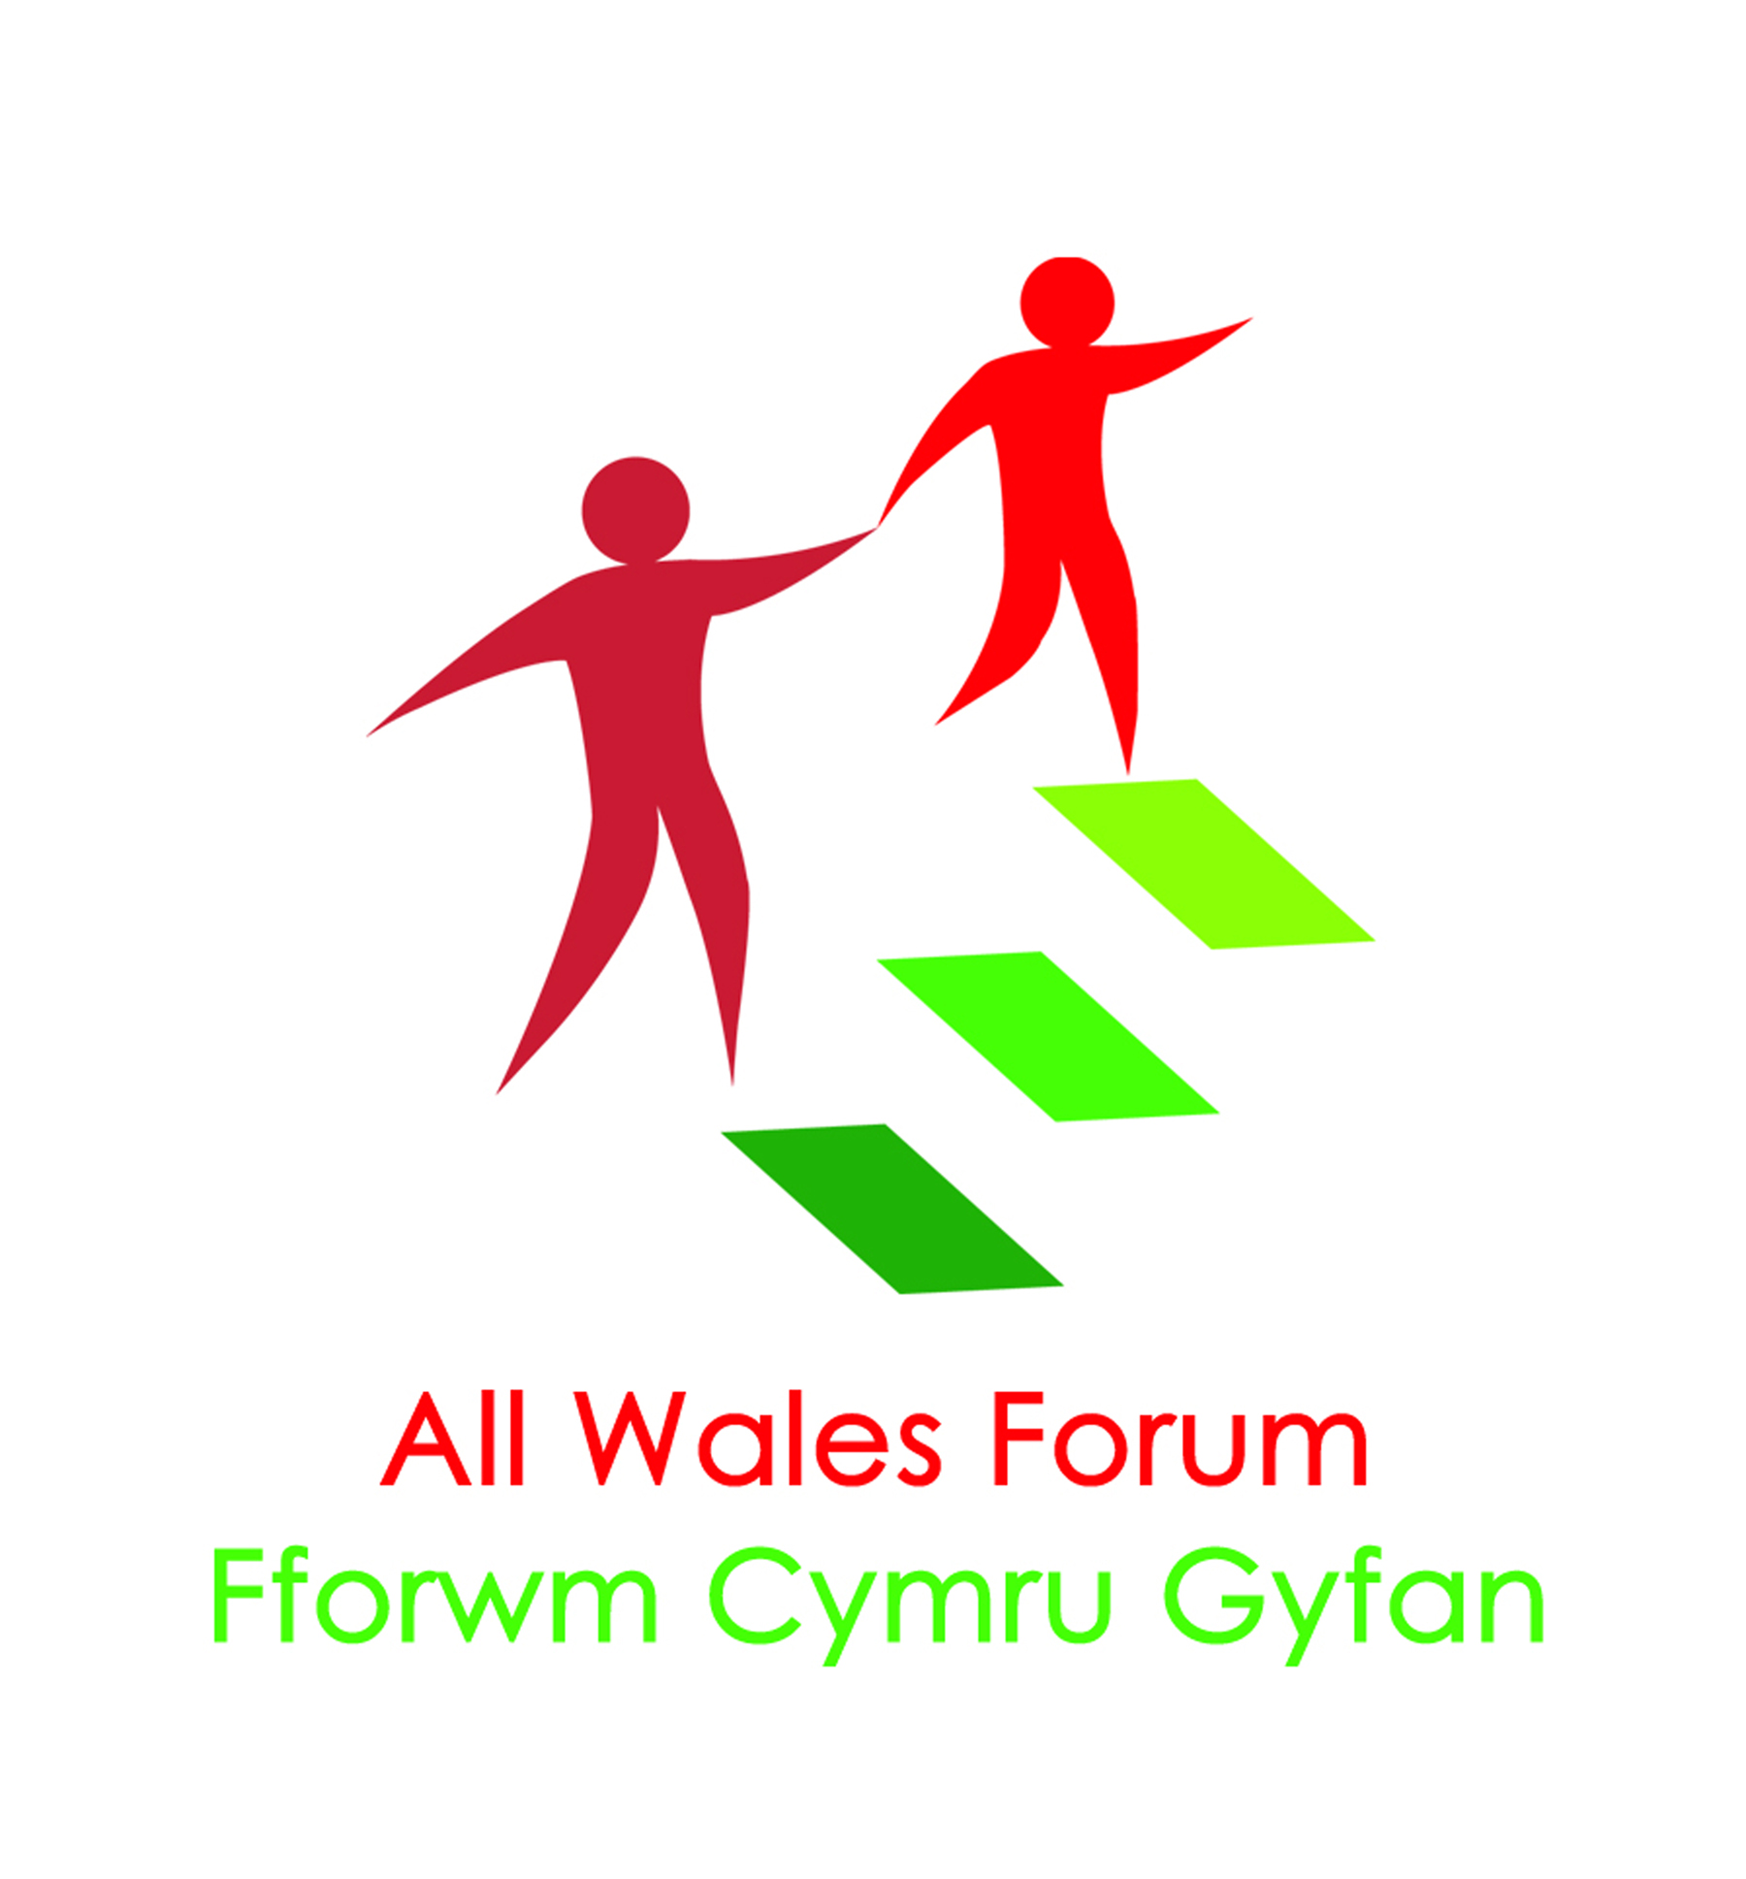
All Together Now

Project Co-ordinator – Ageing Well

Person specification

Essential

- Experience of working with older people and their families

- Experience of leading a project or scheme within the community

- Experience of running/supporting community events

- Experience of working creatively to achieve outcomes required

- Experience of effective problem solving to achieve outcomes required

- Experience of managing conflicts/concerns to a successful resolution

- Evidence of being able to work both on own initiative and as part of a team

- Evidence of using excellent communication and networking skills

- Good understanding of, and experience in using, social media and other promotional platforms

- Experience of managing your own admin processes, including diary, meetings etc

- Evidence of good computer literacy and report writing

- Evidence of working flexibly

Desirable

- Direct experience of working with families living with Learning Disability

- Direct experience of working with Carers

- Direct experience of working within the voluntary sector

- Good knowledge of the Health and Social Care policy agenda for Wales

- Experience of fundraising

- Ability to speak Welsh

