# Your views about Gig Buddies Cymru

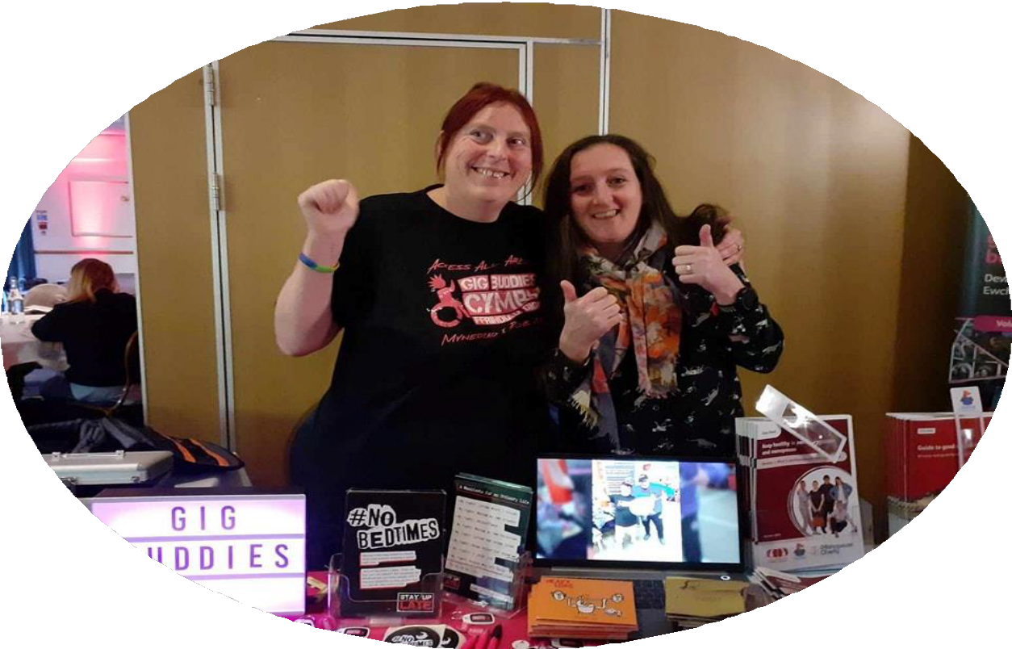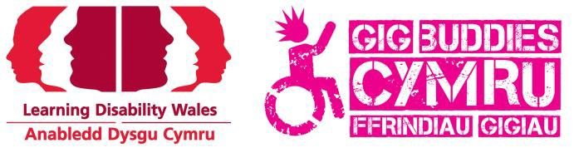

We want to know what people with a learning disability and/or autism think of Gig Buddies Cymru.

We are asking you these questions to help with getting funding for the project.

The things you tell us will help us see how much interest there is in Gig Buddies.

We will ask you some questions, you can do this alone or ask someone for support.

February/March 2024

# What is Gig Buddies Cymru?

Gig Buddies is a friendship project.

We help find a volunteer from your local community, someone who likes the same things as you so you can go out together and have fun!

We work in Gwynedd, Ynys Mon, Conwy, Flintshire, Wrexham, Denbighshire, Bridgend, Vale of Glamorgan RCT , Merthyr and Cardiff.



**About you**



Your name :

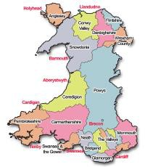

Which County do you live in?



Who do you live with?



If you live in supported living, what

is the name of the provider?



How old are you?



**We want to know about your life now.**

Tell us about your evenings and weekends.

-Who do you go out with?

-Where do you go?

-How often do you go out?



What stops you from going out and doing

the things you want to do?



Would you like to go out more?

What would you like to do?



Do you ever feel lonely? How does it make you feel?



Would you like to make more friends?



Is there anything you would like to tell us about going out?



**About Gig Buddies.**

Have you ever heard about Gig Buddies?

Where did you hear about it?



Would you like a gig buddy? Why?

What would you like to do with a gig buddy?

When would you like to do things with a gig

buddy?



Would you like to meet other people who

are also part of Gig Buddies?



Would you like to help with the project?

We need people to help with things like fundraising, helping on stalls, being part of planning groups and more.

Do you have any ideas?



Is there anything else you would like to say

to Gig Buddies?



Thank you for your help,

The Gig Buddies Cymru team