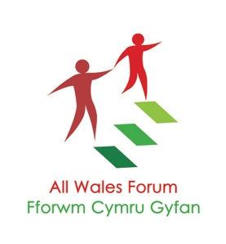
Please note the closing date for applications is Monday 16th March at 10.00am with interviews planned for Wednesday 25th March.
Welcome, and thanks for showing an interest in our vacancy.
The All Wales Forum of Parents and Carers was formally constituted in 1998 and is a Registered Charity and a Company Limited by Guarantee.

The AWF is unique among Learning Disabilities’ bodies in Wales as the only organisation that represents nationally, collectively and solely the views and voices of Parents and Family Carers of People with Learning Disabilities. We are governed by parents and carers, ensuring our client base has a clear input into our strategic direction and core work.

The AWF is an umbrella body made up of a Wales wide alliance of local and regionally based organisations and support groups of parents and carers. Our wider alliance partners share a commitment in working to improve the rights and recognition of family carers supporting loved ones living with a learning disability. We look to identify issues and opportunities at local, regional and national levels where we can come together to raise awareness, discuss solutions and generate innovative community-led ideas, assisting in the future planning of services and support for both carers and their relatives, many of whom still live at home or who are unable to advocate for themselves.

We are a values-based network, working together to enable parents and carers to have an equitable voice and be empowered to make positive decisions in partnership. Our values are carried forward in both the work that we do nationally and in the work of our alliance members.

Our foundation values are:

- Strong Communities
- Empathy and recognition
- Equality and freedom
- Inclusion and Justice
- Teamwork and partnership

We’re now looking for a dynamic and dedicated individual to join our team to lead on our Finance and Governance functions within the organisation. This is a critical role at the heart of what we do, working to ensure we have sound budget management and planning, a strong and well supported charity Board, and good general oversight of our core HR/admin functions.
Please pay attention to the person specification attached to the job description, as we will need you to be able to demonstrate how your work and/or life experience meets the key skills outlined through your personal statement. Please take time to give us practical examples of how you have gained/and or used these skills, so we can get the best sense of who you are and what you can bring.
You may or may not be currently involved in our field of work; but if you are someone with relevant or transferable experience, who likes working to make a difference, is good with figures, well organised, and is prepared to give 100 percent as a key part of our team and our work, then we’d love to hear from you!
The AWF Team and Board.

